Software Requirements Specification

for

Flappy Bird

**Version 1.0**

**Prepared by 20CE066-Hetvi Panara, 20CE050-Prutha Makadia**

**CSPIT-CE**

**22-01-22**

**Table of Contents**

Table of Contents

Table of Contents ii

Revision History ii

1. Introduction 1

1.1 Introduction 1

1.2 Project Scope 1

2. Overall Description 2

2.1 Product Perspective 2

2.2 Product Features 2

2.3 Operating Environment 2

2.4 User Documentation 2

3. System Features 3

3.1 User Interface 3  
3.2 Game Logic 3

4. External Interface Requirements 4

4.1 User Interfaces 4

4.2 Hardware Interfaces 4

4.3 Software Interfaces 4

5. Other Nonfunctional Requirements 5

5.1 Software Quality Attributes 5

**Revision History**

|  |  |  |  |
| --- | --- | --- | --- |
| **Name** | **Date** | **Reason For Changes** | **Version** |
| Flappy bird | 21/1/2022 | First SRS | V 1.1 |
| Flappy bird | 1/1/2022 | Updated required proper documentation and make proper gui | v1.2.1 |

# 1) Introduction

## 1.1 Introduction

Making a joyful game for the children known as flappy bird.

We are designing a game for the children and adults to make them feel relaxed from their studies and workload respectively*.*

## 1.2 Document Conventions

We have chosen fonts and highlighted certain information which will be reader friendly.

## 1.4 Project Scope

This game is just for entertainment for the children and adults when they are bored from their respective work and need some break from their busy schedule.

The game is also to increase the concentration of the children by flying the bird away from the obstacles.

## 1.5 References

[Flappy Bird - Homebrew game for the Nintendo 64 - YouTube](https://www.youtube.com/watch?v=mOAx-qftu1k)

# 2 Overall Description

## 2.1 Product Perspective

Flappy bird game -> within mobile

## 2.2 Product features

* User friendly GUI
* Played only in mobiles
* Effective animation
* Night theme

## 2.4 Operating Environment

Operating environment for our retailed website is as listed below.

Platform: ANDROID

Language: XML, JAVA

## 2.6 User Documentation

Our game is universal. It does not need any login and signup.

# 3 System Features

## 3.1 Game logic

## 3.1.1Description and Priority

The player has to just manage the bird just not to get hit by the obstacles and collect the coins in between.

## 3.1.2Stimulus/Response Sequences

This game is unstoppable. When the bird hits the obstacle then only the game will be over.

**In 1st GUI of our game.**

which will show the bird icon and the name of the game ‘Flappy Bird’.

**In 2nd GUI of our game.**

which contains the score which is the total score scored by the user.

And at last is the start button. After clicking the start button the game will start.

**In 3rd GUI of our game.**

Here the game starts and the game obstacles with coins and bird going along its path.

If the bird gets hit to the obstacles the game ends and the score scored by the user will be show. And the score will be count as we pass bamboos.

The range of increase speed is 25 score, 50 score, 100 score and so on.

**In 4th GUI of our game.**

This GUI appears after clicking the quit button.

And at last, the start button is shown whether if the user wants to play game again.

# External Interface Requirements

## 4.1User Interfaces

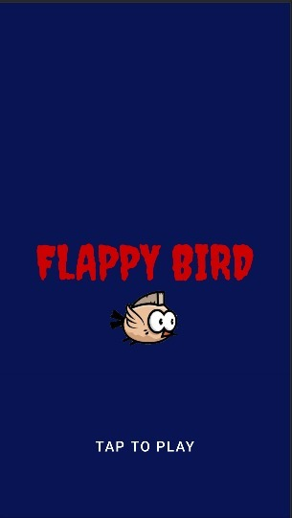**🡪HOME PAGE**

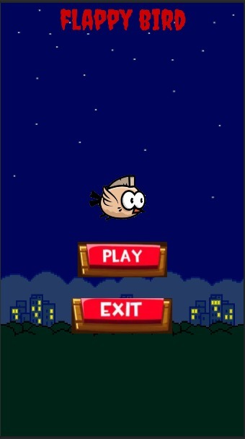**🡪FIRST PAGE**

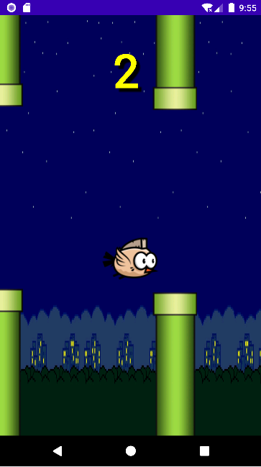**🡪GAME PAGE**

**🡪EXIT PAGE**

## 4.2 Hardware Interfaces

Supported device: Android mobile

## 4.3 Software Interfaces

Following are the software used for our online showroom website.

|  |  |
| --- | --- |
| Software used | Description |
| Operating system | We have chosen android operating system for its best support and user-friendliness. |
| Android | To implement the project we have chosen java language for its more interactive support. |

## 4.4Communications Interfaces

This project supports only android.

# 5 Other Nonfunctional Requirements

## 5.1 Software Quality Attributes

**AVAILABILITY**: -This application is easily available and accessible to the user without any constraints.

**Correctness: -**This application works with full high performance with optimum use of internal memory of machines.

**Flexibility: -**This application works with even if there is no internet because it can be played locally.